Experiment 10
Write a Python Program to Implement Expectation &amp; Maximization Algorithm
Aim
To implement the Expectation–Maximization (EM) algorithm in Python to cluster data points into groups
Program
# Expectation Maximization using Gaussian Mixture Model

import numpy as np
from sklearn.mixture import GaussianMixture

# Dataset
X = np.array([[1],[2],[3],[10],[11],[12]])

# Create EM model
model = GaussianMixture(n_components=2)

# Train model
model.fit(X)

# Predict clusters
labels = model.predict(X)

print("Data Points:", X.flatten())
print("Cluster Labels:", labels)

Output
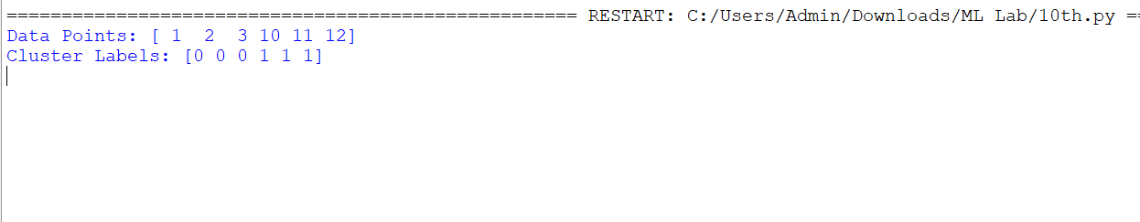

Result
The Expectation–Maximization algorithm was successfully implemented in Python to cluster the given data points into different groups.

